**NARUC Staff Subcommittee on Accounting and Finance**

In-Person Conference

April 7, 2024 to April 10, 2024

**Lucretia Smith, Chair Dolores Midkiff-Powell, Registrar Geoffrey Rush, CPE Coordinator**

**Donn English, Vice-Chair Karen Moran, Secretary**

The National Association of Regulatory Utility Commissioners (NARUC) Staff Subcommittee on Accounting and Finance will be holding its Spring 2024 conference at the Cambria Hotel, Asheville, NC. The purpose of the conference is to provide accounting, finance, and utility regulatory information to personnel with all levels of experience who work in the ever-changing utility regulatory environment.

Open Session for all conferees will be Monday, April 8, 2024 through Wednesday, April 10, 2024. The Closed Session (for subcommittee members and regulatory conferees) will be Thursday morning, April 11, 2024. There is also a Closed Session Sunday evening, April 7, 2024, at 7 p.m.

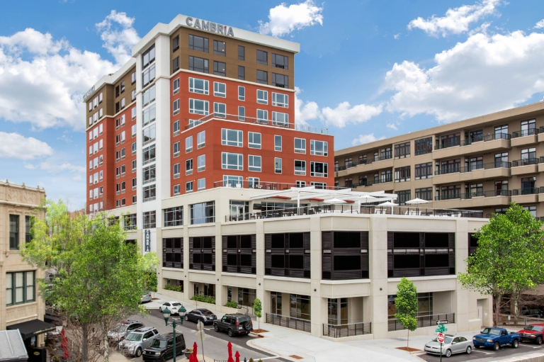

**Cambria Hotel, 15 Page Avenue, Asheville, NC, 28801**

**1(828)348-4850**

**Room Rate: $135**

[**www.choicehotels.com/reservations/groups/YW69F9**](http://www.choicehotels.com/reservations/groups/YW69F9)

The NARUC Staff Subcommittee on Accounting & Finance thanks the AMERICAN GAS ASSOCIATION for sponsoring our FASB speaker and EEI for sponsoring the Monday night networking event.!!

A special THANK YOU to all our speakers and their employers for supporting this conference!!

**Conference Registration to be Available by mid-February - $295 for State Commission attendees and observers; $350 for Industry and Other participants (Breakfast will be included)**

**Discounted Valet Parking available for $7 per night – self-parking not available**

**Tuesday/Wednesday night event TBD**

**Agenda Topics (Final Speakers and Day/Times Still being developed)**

**Sunday, April 7, 2024 (Closed Session)**

* Discussion with FASB Representative

**Monday – Wednesday - Sessions Open to All Attendees except as noted below**

**April 8, 2024 to April 10, 2024**

**8 a.m. to approximately 5 p.m.**

* Welcome from North Carolina Commission
* FASB Update
* Rural Utilities Update
* FERC Update
* Virtual Power Plants - Tesla
* No Net Zero Without Nature - NextGen Energy Partners
* Net Operating Losses/ADIT and FERC and Retail Rates - GDS
* AI and Regulatory Analysis - HData
* Impact of Wildfires - Accounting/Regulation – Avista
* GHG Emission Reporting for the Power Sector - EEI
* Tax and Tax Policy Updates
* KPMG updates on FERC/SEC

**Thursday – Closed Session**

* Legislative Update
* Hot Topics at the North Carolina Commission
* Water USoA Update
* Summary of Staff Subcommittee Surveys
* Upcoming Conference Topics

**LEARNING OBJECTIVES:**

After completion of this conference, you will be able to:

* Identify the current accounting initiatives, standards and projects at FASB relevant to utilities.
* Understand the current issues at the FERC from the Office of Chief Accountant
* Identify the characteristics of programs funded by the Rural Utilities Service and other current issues
* Understand Virtual Power Plants
* Understand emerging issues in the natural gas industry.
* Understand the interaction between net zero and nature
* Understand the requirements for regulatory deferred tax accounting, what they are and how they are treated.
* Identify U.S. legislative issues relevant to utilities and regulators.
* List current regulatory issues before the North Carolina Public Utilities Commission.

**CPE CREDITS**

|  |  |
| --- | --- |
| This conference provides a general review of new accounting pronouncements and issues that affect regulated utilities. The conference presentation method is group-live and the course level is intermediate. Prerequisite: Background in Accounting and Regulatory Issues. There is no advance preparation needed for this conference. The National Association of Regulatory Utility Commissioners (NARUC) is registered with the National Association of State Boards of Accountancy (NASBA) as a sponsor of continuing professional education on the National Registry of CPE Sponsors. State boards of accountancy have final authority on the acceptance of individual courses for CPE Credit. Complaints regarding registered sponsors may be submitted to the National Registry of CPE Sponsors through its website: [www.nasbaregistry.org](http://www.nasbaregistry.org). |  |
| AICPA/NASBA guidelines for CPE credits are based on a 50-minute credit hour in qualifying NASBA CPE subject areas; one credit equals 50 minutes. All breaks and lunches are omitted from the total CPE minutes. Historically, participants that attend all sessions of the program earn an average of 5 CPE hours in the accounting field of study and 18 CPE hours in the specialized knowledge field of study. Based on previous experience, 19 to 21 hours of CPE credits will be available to participants attending the open sessions, with an additional 2 to 3 hours available in the closed sessions. Final CPE earned will be determined based on the length of participation in the program as evidenced through completed attendance forms for each session attended. |  |

|  |  |
| --- | --- |
| Certificate of Continuing Regulatory Education Credits | For public and nonprofit sector employees, full attendance at the program will earn 20 credits toward a Certificate of Continuing Regulatory Education (CCRE) sponsored by the Institute of Public Utilities at Michigan State University and endorsed by the National Association of Regulatory Utility Commissioners. Credits may be earned for up to two programs hosted by the same professional organization and past attendance may be eligible. For program details, please visit ipu.msu.edu/CCRE or contact ipu@msu.edu. |

NARUC’s National Registry of CPE Sponsors Number is 103641

**About Asheville:**

* Average Temperature in April: 68/46
* The nearest airport to Asheville is Asheville (AVL) Airport which is 11.6 miles away. AVL is located just 12 miles from downtown, offers frequent nonstop flights daily to and from 26 destinations, including numerous international hubs, and is served by six airlines: Allegiant, American, Delta, JetBlue, Sun Country, and United.

Other nearby airports include Greenville/Spartanburg (GSP) (52.9 miles), Knoxville (TYS) (82.3 miles) and Charlotte (CLT) (94.9 miles).

* There will be a total solar eclipse on April 8, 2024, which will totally block out the sun from view.

April's total eclipse will occur from around 2-5 p.m., where the eclipse is expected to cover roughly 85% of the sun's disk in the Asheville area, according to Eclipse2024.

Explore Asheville website: <https://www.exploreasheville.com/>